House of LabScience – Version 1.0

Background

As Hombrechtikon Systems Engineering AG has moved from Garstligweg 8 to Garstligweg 6 in Hombrechtikon in the canton of Zurich, Switzerland, the former QIAGEN building is now vacant. The building, which extends over several floors and has its own canteen, is a perfect location for the House of LabScience.

Vision

- A House of LabScience based in Hombrechtikon offers a wide range of benefits for Toolpoint members, the Swiss pharmaceutical industry, the biotech sector, the lab technology sector in Switzerland, the University of Applied Sciences (HSR) in Rapperswil, and the Zurich University of Applied Sciences (ZHAW) in Wädenswil and Winterthur, as well as for all institutions that are active in scientific research and for the economy and scientific sector as a whole in the Greater Zurich Area.
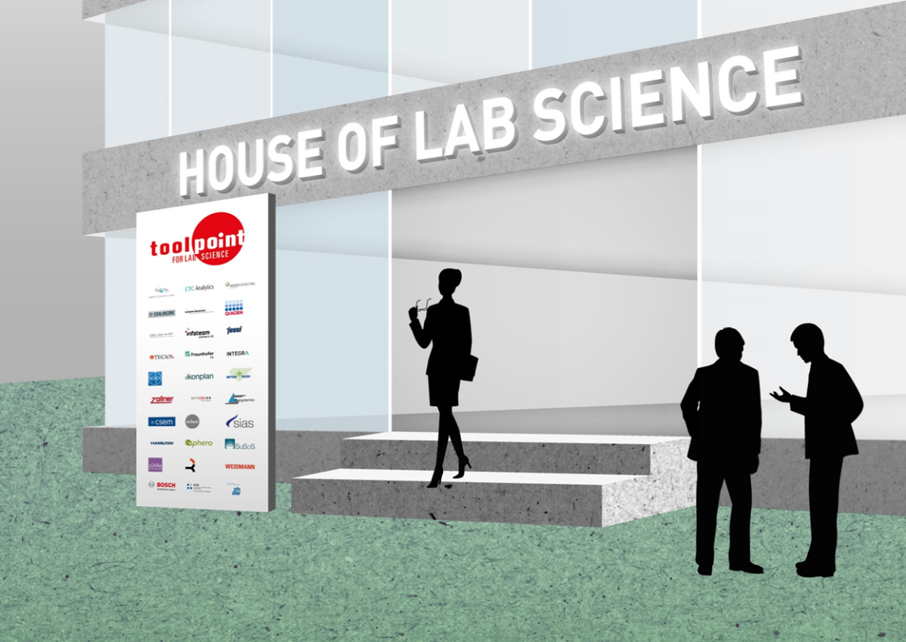

- There are currently around 25,000 jobs in the lab technology sector. Most of the laboratory equipment produced is exported. The sector generates revenues of approximately US $5 billion.

- The House of LabScience will raise awareness of our industry. The building provides an ideal space for close collaboration between research, customer segments and start-ups.

- The Toolpoint network will become even more visible and Toolpoint members will gain even greater benefit from the network.

Who would be interested in the House of LabScience?

The House of LabScience aims to become the centre of innovation in the lab science sector. It is a place where industry, research and universities can come together and develop and implement new ideas, both individually and in collaboration with others. This may include software developers, research centres, developers of measuring and precision technologies, analysts or start-ups. Together with universities and research institutions, the collaborative structure can lead to an astonishing symbiosis that will take the lab science sector to the next level and beyond.

What are the benefits?

The House of LabScience provides a direct link to all companies, research institutions and universities that are located there. Dialogue can take place at any time – ideas and innovations can be implemented and obstacles overcome in-house.

How should it be organised?

As the building extends over several floors, its size means that it can be divided into different sections. The overall mix will include companies pursuing their day-to-day business, start-ups breathing life into their young companies, universities teaching and supporting their students on Bachelor’s, Master’s and further education programmes, such as via internships, as well as research institutions researching, developing and testing their products.

This can and should result in interfaces that will ultimately make the House of LabScience what it should be: a place of dialogue and innovation. One of the aims here is to create common training rooms that can be used by all employees. The very spacious and well-equipped canteen also offers space to exchange ideas over lunch or drinks, and this infrastructure means that large events can be held in collaboration with external companies.
Labs and research rooms will also be set up, which will be open for use by all. These, too, will provide space for open dialogue and a place to develop new ideas.

What conditions must be met in order to create a House of LabScience?

For the House of LabScience to become a reality, there are a few important conditions that need to be met.

- The landlord of the property must be prepared to launch the project.
- At least one university of applied sciences must be prepared to operate an important institute in the House of LabScience.
- A range of backers and stakeholders including politicians, educational institutions and industry players must commit to the project.

Conclusions

In this time of digital transformation, the idea behind the House of LabScience is to create a facility that stands out from the rest and uniquely represents this paradigm shift. The opportunity to realise this vision with a clear focus on innovation is certainly unprecedented. The House of LabScience aims to uniquely reflect the strengths of Swiss industry, business, universities and research.

Pricing details can be found in the following presentation.

Egg, 5 July 2018

Hans Noser
Managing Director, Toolpoint for LabScience

